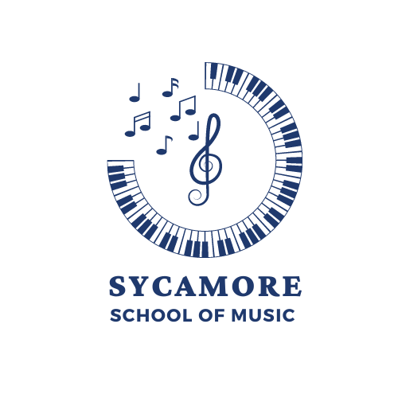

2024 Spring Semester
Individual Lesson Terms and Conditions

Overview
The Sycamore School of Music (SSM) operates on a January 8 to May 17 for 2024 Spring semester. Tuition includes 19 weekly private lessons (30-, 45- or 60 minute duration) and two make-up weeks (May 20-31) over the course of those five months. The tuition and registration fee also supports educational opportunities such as: private and studio recitals, educational and administration support outside of the lesson time.

Individual Lesson Tuition Rates (2024 Spring Semester)
$30 Annual Registration Fee/ per student at enrollment (New Student only)
30 minutes - $665 ($35/lesson)
45 minutes - $1,007($53/lesson)
60 minutes - $1,330 ($70/lesson)

Payment Options
Payments for lesson may be made via cash, check, Visa, or MasterCard.
- 30 min lesson tuition is required in full or two installments due by January 3. The second payment is due by March 15.
- 45 min/60 min lesson tuition can be full or split into two equal payments. The first payment is due by January 3. The second payment is due by March 15.

***Any students registering after the semester start must email the office. Tuition will be prorated and calculated on a per student basis.

Other Fees
- Accounts with past due balance of greater than 15 days will be accessed a $25 late payment fee.
- Accounts with a past due balance will be notified on the 25th day of the month of our intent to discontinue services if the balance is not resolved by the 30th of the month.
- There is a $39 fee for returned checks.

Make up Policy
- 24-hour notice of the cancellation to your instructor is required for a make-up lesson to be scheduled. Cancellations with less than 24-hour notice (or no-shows) will not be made up, nor will any refunds be issued.
- In rare cases of emergency sickness or crisis where 24-hour notice is not possible, please contact your instructor with as much notice as possible. An attempt to make-up lessons due to student illness will be made but is not guaranteed.
- Lessons postponed by the teacher will be made up or taught by a substitute instructor before the end of the semester.
- Generally, faculty are unable to accommodate more than 2 make-up lesson per semester. Students who miss more than 2 lessons per semester are not guaranteed more than 2 make-up lessons and refunds will not be issued.
- Lessons not made up before the end of each session are forfeited.
- All scheduling issues and cancellations must be communicated directly with your
instructor.

Withdrawal Policy
Notice of four weekly lessons (30 days) is required when withdrawing from individual lessons. To discontinue charges to your credit card, notify the office via email (musicschool@sycamorechurch.org) and the instructor. A refund may be issued at the time of withdrawal for any tuition paid beyond the 30-day withdrawal notification. Please remember, individual lessons at SSM are considered a commitment of a semester.

Inclement Weather
In case of inclement weather, the teachers will contact their students. You may also check our website (Sycamorechurch.org) for weather instructions.
Weather closure decisions will not necessarily coincide with the Loveland/Sycamore/Mason Schools.

Safety Policy
This policy attempts to eliminate abuse of minors and vulnerable adults by reducing or eliminate instances where adults and minors might be alone together. The fundamental principle of safety policy is that minors should never be alone with a single adult.

As a response to this policy, a parent/guardian must accompany students under the age of 18 to their lesson. Parents/guardians may sit inside the instruction room or in the hallway within view of the student through the window in the door.
All instructors have had a background check.

